1.

Get a pan

1. Wash pan
2. Pour 15 ML oil in pan
3. Put it on stove and turn flame on to moderate amount(size)
4. While waiting break the eggs
5. Whisk the eggs thoroughly until all of it turns yellow
6. When oil is hot enough, pour eggs into pan
7. Wait 1-2 minutes and turn over. Repeat this process once more.

2.Idle is both a compiler and an interpreter. This is due to the reason that it allows you to type in commands and have them executed, resulting in enabling one to view their outcomes

3. 

4. 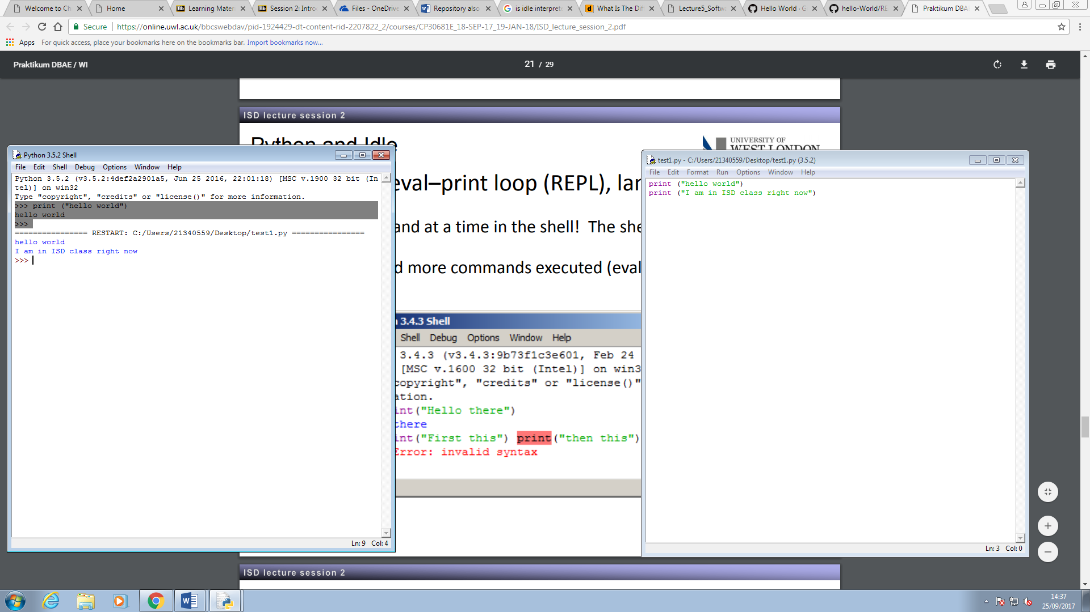

5.